Project Design Phase
Problem – Solution Fit Template

Date | 29 September 2026
Team ID | SWTID-2026-7933
Project Name | AI FAQ Assistant
Maximum Marks | 2 Marks

Problem – Solution Fit Template:
The Problem-Solution Fit simply means that you have found a problem with your customer and that the solution you have realized for it actually solves the customer’s problem. It helps entrepreneurs, marketers and corporate innovators identify behavioral patterns and recognize what would work and why
Purpose:
❑ Solve complex problems in a way that fits the state of your customers.
❑ Succeed faster and increase your solution adoption by tapping into existing mediums and channels of behavior.
❑ Sharpen your communication and marketing strategy with the right triggers and messaging.
❑ Increase touch-points with your company by finding the right problem-behavior fit and building trust by solving frequent annoyances, or urgent or costly problems.
❑ Understand the existing situation in order to improve it for your target group.

Template:
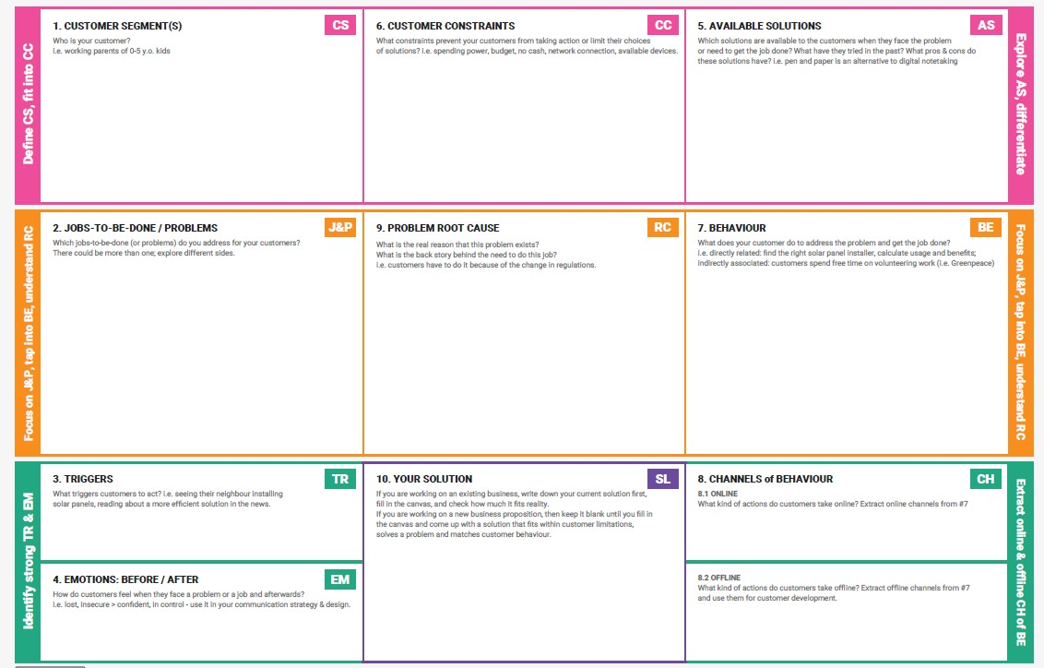
1. CUSTOMER SEGMENT(S)
Idhula type panna:
College students, staff and other users who need quick answers to frequently asked questions.
JOBS-TO-BE-DONE / PROBLEMS
Users need quick, accurate and simple answers to frequently asked questions without spending much time searching for information
TRIGGERS
Users have a question and need an immediate answer or information.
EMOTIONS: BEFORE → AFTER
Before: Confused and frustrated when searching for answers.
After: Satisfied and confident after getting a quick answer.
AVAILABLE SOLUTIONS
FAQ pages, search engines, websites and chatbots are available, but they may not always provide simple and direct answers.
EXISTING ALTERNATIVES
Manual searching, FAQ websites, Google Search and asking staff or support teams.
VALUE PROPOSITION
AI-powered FAQ Assistant that provides quick, accurate and easy-to-understand answers to users' questions
SOLUTION
An AI chatbot that understand user questions and providers relevant answers from the available FAQ information
CHANNELS
Web application,college website and student portal

- https://www.ideahackers.network/problem-solution-fit-canvas/
- https://medium.com/@epicantus/problem-solution-fit-canvas-aa3dd59cb4fe

